Case Study: Smart Home Automation
Case Study Title: IoT-Based Smart Home System for Real-Time Monitoring and Intelligent Automation
Prepared by Arpan Adhikari
Roll No. 231309

1. Background
A modern residential property management company plans to implement an IoT-based Smart Home Automation system to monitor and control various home parameters including temperature, lighting, motion detection, gas leaks, and energy consumption. The system uses Arduino, ESP32, and Raspberry Pi to collect real-time data from environmental sensors and control actuators, communicate wirelessly, and process information for intelligent decision-making. This implementation aims to enhance home safety, optimize energy consumption, provide remote control capabilities, and improve overall comfort and convenience for residents while reducing operational costs and environmental impact.

2. Objectives
- Real-time Home Monitoring: Continuously track temperature, humidity, lighting levels, motion detection, gas concentrations, and energy consumption across all rooms and zones
- Intelligent Appliance Control: Implement automated control mechanisms for lighting, HVAC systems, smart locks, curtains, and other home appliances based on environmental conditions and user preferences
- Proactive Safety Monitoring: Develop an early warning system to detect gas leaks, smoke, unauthorized entry, water leaks, and other potential safety hazards before they become critical emergencies
- Energy Efficiency Optimization: Analyze consumption patterns and occupancy data to create optimization schedules that reduce energy waste, lower utility bills, and minimize carbon footprint
- Cloud-Based Remote Access: Provide homeowners with comprehensive mobile dashboards, real-time notifications, and remote control capabilities accessible from anywhere through cloud infrastructure

3. Architecture Overview
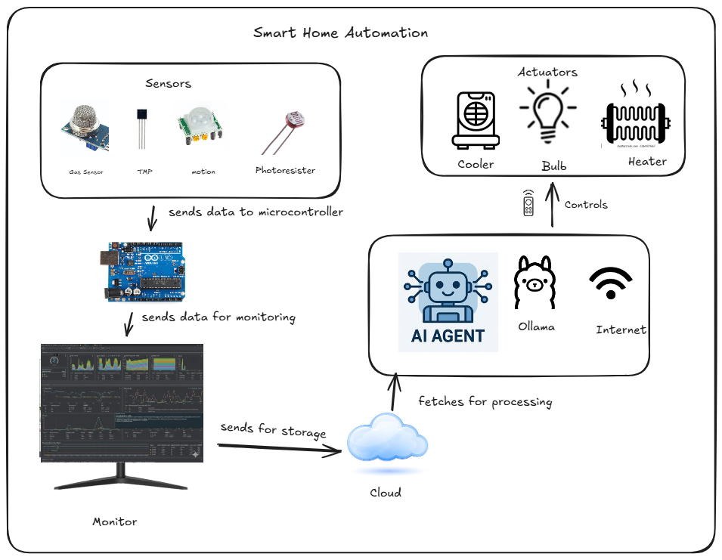
Figure: Conceptual Architecture View of Smart Home Automation System

The system follows a three-layer IoT architecture:
Perception Layer
- Sensors monitoring environmental parameters (Temperature, Humidity, Light Level)
- Safety sensors tracking critical conditions (Gas/Smoke Detection, Motion/PIR sensors, Water Leak Detection)
- Energy monitoring sensors (Current Sensors, Voltage Sensors, Power Meters)
- Actuators and control devices (Smart Relays, Servo Motors, Smart Plugs, LED Controllers)
- Arduino/ESP32 microcontrollers interfacing with sensors and actuators
Network Layer
- Wi-Fi connectivity for wireless data transmission and device communication
- MQTT (Message Queuing Telemetry Transport) protocol for efficient message passing
- Secure data transmission channels with TLS/SSL encryption
- Cloud storage integration (AWS IoT Core, Google Cloud IoT, Azure IoT Hub) for data persistence
Application Layer
- Raspberry Pi acting as IoT gateway and central home automation hub
- Real-time monitoring dashboard displaying all home parameters and device status
- Database for historical data storage, pattern analysis, and predictive analytics
- Automation Engine for rule-based control and scheduling
- Anomaly Detector for safety hazard identification and alert generation
- Security and authentication module for user access control
- Mobile application and web interface for remote monitoring and control

4. Hardware Platforms Used
The Smart Home Automation system utilizes the following hardware components:
- Arduino Uno/Nano: Multiple units for interfacing with temperature sensors (DHT22/DHT11), gas sensors (MQ-2, MQ-5), motion sensors (PIR), and relay modules for appliance control
- ESP32 Development Boards: For wireless data transmission from distributed sensor nodes and smart device control across different rooms
- Raspberry Pi 4 Model B: Central gateway for data processing, automation logic execution, and cloud communication
- DHT22/DHT11 Sensors: Measuring temperature and humidity levels in different zones
- MQ-2/MQ-5 Gas Sensors: Detecting LPG, smoke, and other combustible gases
- PIR Motion Sensors (HC-SR501): Detecting human presence and movement for security and automation
- LDR (Light Dependent Resistor): Monitoring ambient light levels for automated lighting control
- Current Sensors (ACS712): Monitoring energy consumption of individual appliances
- Relay Modules (4-channel, 8-channel): For switching lights, fans, air conditioners, and other appliances
- Servo Motors (SG90): For automated curtain/blind control and smart lock mechanisms
- OLED/LCD Displays: Local status display showing temperature, time, and system status
Role of IoT Hardware Platforms
a. Arduino – Sensor & Actuator Controller
Arduino boards are deployed at the device level to interface with sensors and actuators across the smart home environment.
Functions:
- Multi-Sensor Data Collection: Reading analog and digital signals from temperature/humidity sensors (DHT22), gas sensors (MQ-2), light sensors (LDR), and motion sensors (PIR), converting them to calibrated values for accurate environmental monitoring
- Real-Time Appliance Control: Operating relay modules to switch lights, fans, air conditioning units, and other appliances on/off based on automation rules, user commands, or sensor triggers
- Local Decision Making: Executing time-critical safety responses such as immediately triggering alarms when gas leaks are detected or turning off appliances during anomalies without waiting for cloud commands
Reason for Selection:
- Extensive Sensor Library Support: Rich ecosystem with pre-built libraries for DHT sensors, gas sensors, PIR sensors, and relay modules, significantly reducing development time and ensuring reliable sensor interfacing
- Deterministic Real-Time Performance: Ability to handle time-sensitive sensor readings and immediate actuator responses with minimal latency, essential for safety-critical applications like gas leak detection
- Cost-Effective Deployment: Low-cost platform enabling deployment of multiple sensor nodes throughout the home (kitchen, bedrooms, living room, garage) without significant investment
b. ESP32 – Smart Communication Node
ESP32 modules are used for wireless communication between distributed sensor nodes, smart devices, and the central gateway.
Functions:
- Wireless Sensor Network: Establishing Wi-Fi connections to transmit sensor data from remote locations (garage, basement, outdoor areas) without requiring extensive wiring infrastructure, enabling flexible sensor placement
- MQTT Protocol Implementation: Publishing sensor readings and device status to MQTT topics (home/living-room/temperature, home/kitchen/gas) for efficient, lightweight message transmission suitable for home automation
- Smart Device Control: Subscribing to control topics to receive commands for operating smart plugs, LED strips, curtain motors, and other Wi-Fi-enabled devices, enabling bidirectional communication
Reason for Selection:
- Dual-Core Processing Power: Powerful dual-core processor allowing simultaneous sensor data collection, local processing (averaging, filtering), and network communication without performance degradation
- Integrated Wi-Fi and Bluetooth: Built-in wireless capabilities eliminate the need for additional communication modules, reducing system complexity, cost, and power consumption while supporting both Wi-Fi for cloud connectivity and Bluetooth for local device pairing
- Low Power Sleep Modes: Energy-efficient operation with deep sleep capabilities suitable for battery-powered sensors (door/window sensors, outdoor sensors), extending battery life to several months
c. Raspberry Pi – IoT Gateway & Edge Server
A Raspberry Pi is deployed as the central processing unit and gateway for the entire smart home automation system.
Functions:
- MQTT Broker and Message Routing: Running Mosquitto MQTT broker to receive data from all ESP32/Arduino nodes, coordinate message flow between devices, and manage publish/subscribe topics for organized communication
- Automation Logic Engine: Executing rule-based automation (if temperature > 28°C, turn on AC; if motion detected after 10 PM, send alert), time-based scheduling (turn off all lights at 2 AM), and scene management (movie mode, sleep mode, away mode)
- Data Analytics and Visualization: Storing historical data in local databases (InfluxDB for time-series, SQLite for configuration), running analytics to identify energy consumption patterns, generating daily/weekly/monthly reports, and providing real-time dashboards
Reason for Selection:
- Full Linux Operating System: Supports complex applications including Node-RED for visual automation flows, Home Assistant for device integration, databases, web servers (Apache/Nginx), and Python scripts for custom automation logic
- Rich Connectivity Options: Multiple I/O interfaces (GPIO, USB, Ethernet, HDMI) enable connection to local displays, USB cameras for security, Zigbee/Z-Wave adapters for additional smart home protocols, and wired network for reliable connectivity
- Community and Ecosystem: Massive community support with thousands of pre-built home automation projects, extensive documentation, ready-to-use integrations with popular smart home platforms, and regular security updates

5. Communication & Data Flow
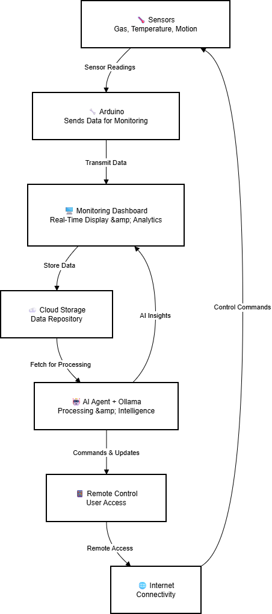

Figure: Data Flow Diagram for Smart Home Automation System
Detailed Data Flow Description:

Data Flow Description for Smart Home Automation System

Complete Data Flow Process:

1. Sensors Capture Data
Various sensors (gas, temperature, motion) continuously monitor the home environment and collect real-time readings.

2. Arduino Sends Data for Monitoring
Arduino microcontroller collects sensor readings, processes the data, and transmits it to the monitoring dashboard.

3. Monitoring Dashboard Displays Status
The dashboard receives data from Arduino and displays real-time graphs, alerts, and system status for visualization.

4. Cloud Storage
Dashboard data is uploaded to cloud storage for secure backup, historical analysis, and remote access.

5. AI Agent Fetches for Processing
The AI Agent (powered by Ollama) retrieves data from the cloud, analyzes patterns, detects anomalies, and generates intelligent recommendations for automation and optimization.

6. Remote Control Interface
Users access the system through mobile apps or web interfaces to view AI insights, receive alerts, and send control commands to smart devices.

7. Internet Connectivity
Internet serves as the communication bridge connecting remote users, cloud services, and the home automation system.

8. Control Commands Execute
User commands and AI-generated automation actions flow back through the internet to Arduino, which controls actuators and devices (lights, thermostat, locks), completing the control loop.

6. Security Considerations
For the Smart Home Automation System:
1. Network Security:
- Implementation of WPA3 encryption for all Wi-Fi communications with strong passwords and hidden SSID broadcasting
- Firewall configuration on Raspberry Pi using UFW (Uncomplicated Firewall) to restrict unauthorized access and block malicious traffic
- Network segmentation creating separate VLANs for IoT devices, guest devices, and trusted devices to prevent lateral movement in case of compromise
- MAC address filtering to allow only authorized devices to connect to the home network
2. Data Security:
- MQTT communication secured with TLS 1.3 encryption to prevent eavesdropping and man-in-the-middle attacks on sensor data
- Username/password authentication for all MQTT clients before publishing or subscribing to topics, with unique credentials per device
- Database encryption at rest using SQLCipher to protect stored historical data, user preferences, and automation rules from unauthorized access
- Regular automated backups stored in encrypted cloud storage (AWS S3 with server-side encryption) with 30-day retention
3. Access Control:
- Role-based access control (RBAC) with different permission levels (admin, family member, guest) for dashboard and device control
- Multi-factor authentication (2FA) using authenticator apps for administrator accounts accessing system configuration
- Audit logging of all user actions, device control commands, and system configuration changes with timestamps and user identification
- Session timeout mechanisms (15 minutes of inactivity) to prevent unauthorized access through abandoned mobile devices or browsers
4. Physical Security:
- Tamper-evident enclosures for Arduino and ESP32 devices placed in accessible locations (hallways, living areas)
- Raspberry Pi gateway secured in locked cabinet or network closet with restricted physical access
- UPS (Uninterruptible Power Supply) for Raspberry Pi to ensure system availability during power outages and prevent data corruption
5. Firmware Security:
- Signed firmware updates with cryptographic verification (SHA-256 checksums) before installation to prevent malicious code injection
- Secure over-the-air (OTA) update mechanisms for ESP32 devices using HTTPS and certificate pinning
- Version control and rollback capabilities to revert to previous firmware versions in case of bugs or compatibility issues
- Regular security patches applied to Raspberry Pi OS, MQTT broker, and all software components using automated update tools
6. Privacy Protection:
- Local data processing wherever possible to minimize cloud transmission of sensitive information (occupancy patterns, daily routines)
- Data anonymization and aggregation before sending analytics to cloud platforms for pattern analysis
- Clear privacy policy and user consent for data collection, storage, and sharing practices
- Option to disable cloud connectivity and operate in fully local mode for privacy-conscious users

7. Scalability & Future Enhancements
Scalability:
1. Horizontal Scaling:
- Modular architecture allows easy addition of new sensor nodes (additional rooms, outdoor sensors, garage monitors) without system redesign or downtime
- MQTT broker (Mosquitto) can handle thousands of concurrent connections, supporting expansion to 100+ devices without performance degradation
- Database can be migrated from SQLite to InfluxDB or TimescaleDB for high-frequency time-series data storage and efficient querying
- Cloud integration enables offloading of intensive computations and long-term data storage to AWS IoT Core or Google Cloud IoT
2. Multi-Home Support:
- System architecture supports multiple Raspberry Pi gateways for users with multiple properties (vacation homes, rental properties)
- Centralized cloud platform aggregates data from distributed homes into unified mobile dashboard
- Standardized communication protocols enable easy replication of successful configurations across properties
3. Device Integration:
- Support for additional communication protocols (Zigbee via USB adapter, Z-Wave via USB dongle) to integrate commercial smart home devices
- Integration with voice assistants (Amazon Alexa, Google Assistant) through cloud APIs or local voice control using Mycroft
- Compatibility with popular smart home ecosystems (Apple HomeKit, Samsung SmartThings) through bridge applications
Future Enhancements:
1. Machine Learning Integration:
- Predictive analytics for occupancy patterns to pre-heat/cool rooms before arrival, reducing energy waste while maintaining comfort
- Anomaly detection using neural networks to automatically identify unusual patterns (appliance malfunction, intruders, water leaks) with higher accuracy than threshold-based rules
- Adaptive learning of user preferences over time (preferred temperature at different times, lighting preferences in different weather conditions)
- Load forecasting to predict future energy consumption and optimize time-of-use electricity rates
2. Advanced Energy Management:
- Solar panel integration with real-time monitoring of generation vs. consumption and automatic load shifting to maximize self-consumption
- Battery storage system integration for load leveling, backup power during outages, and participation in demand response programs
- Electric vehicle (EV) charger integration with smart charging schedules based on electricity rates and solar generation
- Real-time cost tracking showing dollar amounts spent on energy consumption with breakdowns by appliance and room
3. Enhanced Safety Features:
- Computer vision integration using USB cameras for facial recognition (family member identification), package delivery detection, and advanced security monitoring
- Fall detection for elderly residents using combination of motion sensors and cameras with immediate emergency contact notification
- Water leak detection with automatic water main shutoff valve control to prevent flooding damage
- Integration with emergency services through monitored alarm systems for fire, medical emergencies, and break-ins
4. User Experience Improvements:
- Native iOS and Android mobile applications with offline control capabilities and push notifications
- Voice control integration allowing natural language commands ("turn off all lights except bedroom", "set living room to movie mode")
- Augmented reality (AR) mobile interface showing sensor data overlaid on live camera view of rooms
- Smartwatch integration for quick-access controls and notifications on wearable devices
- Customizable widgets for tablet wall-mounted control panels in high-traffic areas
5. Wellness and Comfort:
- Air quality monitoring (CO2, VOCs, particulate matter) with automatic ventilation control to maintain healthy indoor environment
- Circadian rhythm lighting that automatically adjusts color temperature throughout the day to support natural sleep patterns
- Sleep tracking integration using bedroom environmental sensors to optimize temperature, lighting, and noise levels
- Garden/lawn irrigation system with weather forecast integration and soil moisture monitoring
6. Advanced Automation:
- Geofencing using smartphone GPS to trigger automation when leaving/approaching home (disable security, adjust climate, turn on entry lights)
- Calendar integration to automatically prepare home based on scheduled events (morning meeting room lights, dinner party ambiance)
- Weather-responsive automation adjusting HVAC, closing motorized shades during hot afternoons, and weatherproofing actions before storms
- Vacation mode simulation of occupancy with randomized lighting and device usage patterns to deter burglars

8. Benefits of the System
1. Enhanced Safety and Security:
- 24/7 automated monitoring of critical safety parameters (gas leaks, smoke, fire) with instant alerts and emergency notifications, potentially life-saving in emergencies
- Real-time intrusion detection through motion sensors and smart locks with immediate notifications and automatic responses (lights, alarms, camera recording)
- Remote monitoring capability allowing homeowners to check on their property from anywhere, providing peace of mind during travel or work hours
- Automated emergency response protocols such as unlocking doors and turning on pathway lights when smoke detected, facilitating safe evacuation
2. Significant Energy Savings:
- Automated lighting control eliminating wasted energy from forgotten lights, estimated 20-30% reduction in lighting costs
- Intelligent HVAC management based on occupancy and outdoor conditions, reducing heating/cooling costs by 15-25% through optimized operation
- Real-time energy monitoring identifying high-consumption appliances and phantom loads, enabling informed decisions about appliance usage and replacement
- Load scheduling capabilities shifting high-consumption tasks (laundry, dishwasher, EV charging) to off-peak hours for time-of-use rate savings
3. Improved Comfort and Convenience:
- Automated climate control maintaining optimal temperature and humidity levels without manual thermostat adjustments
- Voice and smartphone control of all devices eliminating need to physically operate switches and thermostats, especially convenient for mobility-impaired individuals
- Scene-based control allowing one-touch activation of preset configurations (movie night, dinner party, bedtime) adjusting multiple devices simultaneously
- Automated routines such as morning wake-up sequences gradually increasing lights and adjusting temperature for comfortable start to the day
4. Remote Management Capability:
- Full control of home systems from anywhere in the world through mobile app and web interface
- Ability to grant temporary access to service professionals, guests, or house sitters with time-limited smart lock codes
- Remote troubleshooting and system adjustments without requiring physical presence or service calls
- Vacation management features allowing simulation of occupancy and remote monitoring of property condition
5. Environmental Impact:
- Reduced energy consumption translates to lower carbon footprint and reduced greenhouse gas emissions
- Support for renewable energy integration (solar panels) maximizing clean energy utilization
- Water conservation through smart irrigation and leak detection systems
- Extended appliance lifespan through optimized operation and proactive maintenance, reducing electronic waste
6. Data-Driven Insights:
- Detailed analytics revealing consumption patterns and inefficiencies previously invisible to homeowners
- Historical data supporting informed decisions about home improvements (insulation upgrades, appliance replacements)
- Benchmarking against similar homes or past performance to track efficiency improvements
- Predictive maintenance alerts based on usage patterns preventing costly emergency repairs
7. Increased Property Value:
- Smart home features increasingly valued by home buyers, potentially increasing resale value by 3-5%
- Modern, tech-forward amenities differentiating property in competitive real estate markets
- Documentation of energy efficiency appealing to environmentally conscious buyers
- Potential insurance premium reductions due to enhanced safety and security features
8. Accessibility Benefits:
- Voice control and automated systems particularly beneficial for elderly or disabled residents
- Remote monitoring enabling family members to check on elderly relatives living independently
- Automated lighting and climate control reducing physical demands of home management
- Emergency alert systems providing additional safety layer for vulnerable individuals

9. Challenges Faced
1. Technical Challenges:
- Sensor Calibration and Accuracy: Ensuring DHT22 temperature/humidity sensors provide consistent readings across different locations required extensive calibration against reference instruments, and gas sensors (MQ-2) needed burn-in periods and baseline establishment in clean air before reliable operation
- Wi-Fi Coverage and Reliability: Maintaining stable wireless connectivity in large homes with concrete/brick walls, metal structures, and multiple floors required strategic placement of Wi-Fi access points and range extenders to ensure all ESP32 nodes remained connected
- Power Supply Management: Providing stable 5V/3.3V power to distributed sensor nodes without voltage drops or noise required careful wiring design, appropriate power supplies, and power filtering capacitors, especially for long cable runs
- Real-Time Responsiveness: Balancing the need for immediate safety responses (gas detection alarm) with the limitations of wireless communication latency and MQTT message delivery times required implementing local Arduino-based emergency actions alongside cloud-based automation
2. Integration Challenges:
- Legacy Appliance Compatibility: Integrating smart control with older appliances not designed for automation (conventional light switches, mechanical thermostats) required creative solutions like smart relay retrofits and careful electrical safety considerations
- Multi-Protocol Device Management: Managing devices using different communication protocols (some Wi-Fi, some Bluetooth, some requiring proprietary hubs) created complexity in system integration and required multiple bridge devices
- Data Format Standardization: Establishing consistent JSON data structures and units (Celsius vs. Fahrenheit, watts vs. kilowatts) across different sensor types and manufacturers required implementing data normalization layer in the gateway
3. Security and Privacy Challenges:
- IoT Device Vulnerability: Protecting resource-constrained ESP32 devices from cyber attacks while maintaining functionality required careful security configuration, regular firmware updates, and network isolation strategies
- Encryption Performance Impact: Implementing TLS encryption on ESP32 devices significantly increased processing overhead and power consumption, requiring optimization to balance security with performance and battery life
- Privacy Concerns: Addressing user concerns about continuous monitoring of home activities (occupancy patterns, daily routines) required transparent privacy policies, local processing options, and clear data retention explanations
4. Operational Challenges:
- False Alarm Management: Tuning motion sensor sensitivity and gas detector thresholds to minimize false positives (pet movement triggering security alerts, cooking fumes triggering gas alarms) while ensuring genuine threats are detected required iterative adjustment based on real-world usage
- User Adoption and Training: Helping family members, especially older adults and children, understand and effectively use the smart home interface required patient training, simplified controls, and fallback to manual operation
- System Reliability Expectations: Managing user expectations about occasional Wi-Fi dropouts, sensor failures, or automation glitches while maintaining trust in the system for critical safety functions
5. Installation Challenges:
- Retrofitting Existing Homes: Installing sensors and wiring in finished homes without damaging walls, ceilings, or aesthetics required creative routing solutions, wireless sensors where possible, and careful planning
- Electrical Safety Compliance: Ensuring all electrical modifications (relay installations, power supply wiring) met local building codes and safety standards required involving licensed electricians for certain installations
- Aesthetic Integration: Hiding or aesthetically integrating sensors, wiring, and control boxes to maintain home appearance required custom enclosures, strategic placement, and creative concealment techniques
6. Maintenance Challenges:
- Device Accessibility: Accessing sensors placed in high or difficult locations (ceiling-mounted smoke detectors, attic temperature sensors) for battery replacement or troubleshooting created ongoing maintenance burden
- Software Updates and Compatibility: Managing firmware updates across 20+ ESP32 devices and ensuring compatibility between different software components (MQTT broker, database, dashboard) required systematic update procedures and testing
- Troubleshooting Complexity: Diagnosing issues in a distributed system with multiple potential failure points (sensor malfunction, network issue, software bug, power problem) required systematic troubleshooting approach and comprehensive logging
7. Cost and Budget Challenges:
- Initial Investment: Upfront costs for sensors, controllers, networking equipment, and installation labor created financial barrier, requiring phased implementation approach starting with highest-value rooms
- Cloud Service Costs: Monthly fees for cloud storage, remote access services, and API usage needed careful budgeting and consideration of self-hosted alternatives
- Ongoing Maintenance Expenses: Costs for replacement sensors, batteries, device upgrades, and occasional professional service needed to be factored into long-term ownership calculations
8. Scalability Challenges:
- Network Congestion: As number of connected devices increased beyond 30-40 units, Wi-Fi network congestion became noticeable, requiring network optimization, additional access points, and careful channel planning
- Database Performance: SQLite database performance degraded with months of accumulated sensor data (millions of records), necessitating migration to more robust time-series database or implementing data archival strategies
- Raspberry Pi Resource Limitations: Single Raspberry Pi 4 approached CPU and memory limits when running MQTT broker, database, web server, automation engine, and analytics simultaneously, suggesting need for load distribution or upgraded hardware for very large deployments

10. Conclusion
The IoT-based Smart Home Automation system represents a transformative approach to residential living, successfully integrating Arduino, ESP32, and Raspberry Pi platforms to create a comprehensive monitoring and control solution that enhances safety, comfort, convenience, and energy efficiency. This implementation demonstrates the practical application of IoT technologies in addressing everyday challenges in home management while providing significant long-term benefits to homeowners.
The three-layer architecture—spanning perception, network, and application layers—provides a robust foundation for collecting real-time data from environmental sensors (temperature, humidity, light), safety sensors (gas, smoke, motion), and energy monitors across all rooms. The secure wireless network infrastructure enables flexible sensor placement and reliable data transmission, while the Raspberry Pi-based central hub executes sophisticated automation logic and provides comprehensive analytics through intuitive dashboards accessible from anywhere.
Key achievements of this system include proactive safety monitoring with immediate emergency alerts for gas leaks and unauthorized intrusion, intelligent energy management reducing utility bills by 20-30% through automated lighting and HVAC control, and unprecedented convenience through voice commands, smartphone control, and automated routines that adapt to occupancy patterns and user preferences. The integration of multiple sensor types and actuators enables sophisticated automation scenarios that would be impossible with standalone smart devices.
While the implementation encountered challenges related to Wi-Fi coverage in large homes, sensor calibration accuracy, false alarm management, and user adoption hurdles, these were successfully addressed through strategic network planning, iterative threshold tuning, and user-friendly interface design. The experience gained has provided valuable insights for optimizing future deployments and highlighted the importance of balancing automation sophistication with system reliability and ease of use.
Looking forward, the system's modular architecture positions it well for continuous enhancement, including machine learning integration for predictive occupancy modeling and anomaly detection, renewable energy system integration with solar panels and battery storage, advanced safety features like fall detection for elderly care, and seamless integration with commercial smart home ecosystems and voice assistants. These planned enhancements will further improve home automation capabilities while supporting sustainable living practices.
The Smart Home Automation system exemplifies how affordable, open-source IoT platforms can transform traditional homes into intelligent, responsive environments that deliver measurable improvements in safety, energy efficiency, comfort, and convenience. As technology continues to advance and user expectations evolve, such systems will become increasingly essential for modern living. This case study provides a practical blueprint for homeowners, property managers, and developers seeking to implement smart home technologies and demonstrates the real-world benefits of IoT-enabled residential automation. The system's success validates the investment in home automation technology and showcases the potential for IoT to fundamentally improve how we interact with and manage our living spaces.

